SELECT MAX(salary)

FROM lit;

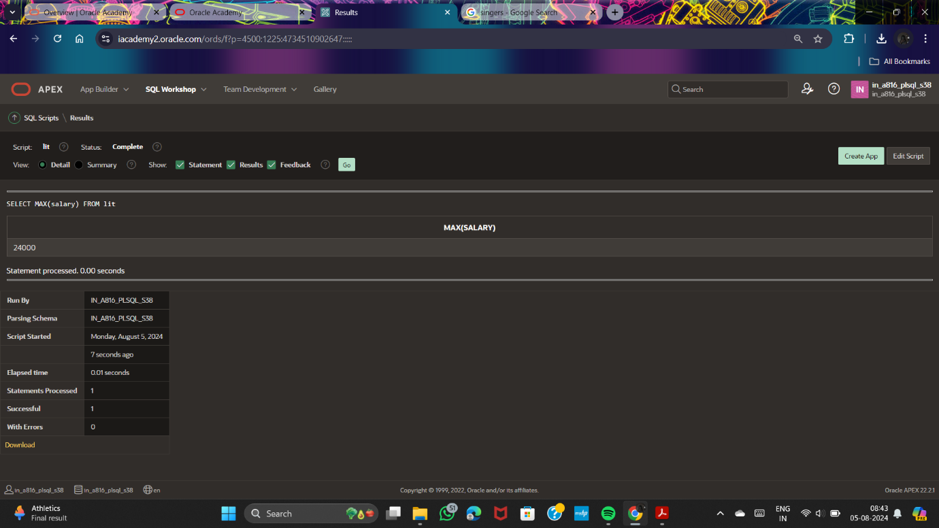

SELECT dept_id

FROM lit

WHERE salary>=1000

GROUP BY dept_id;

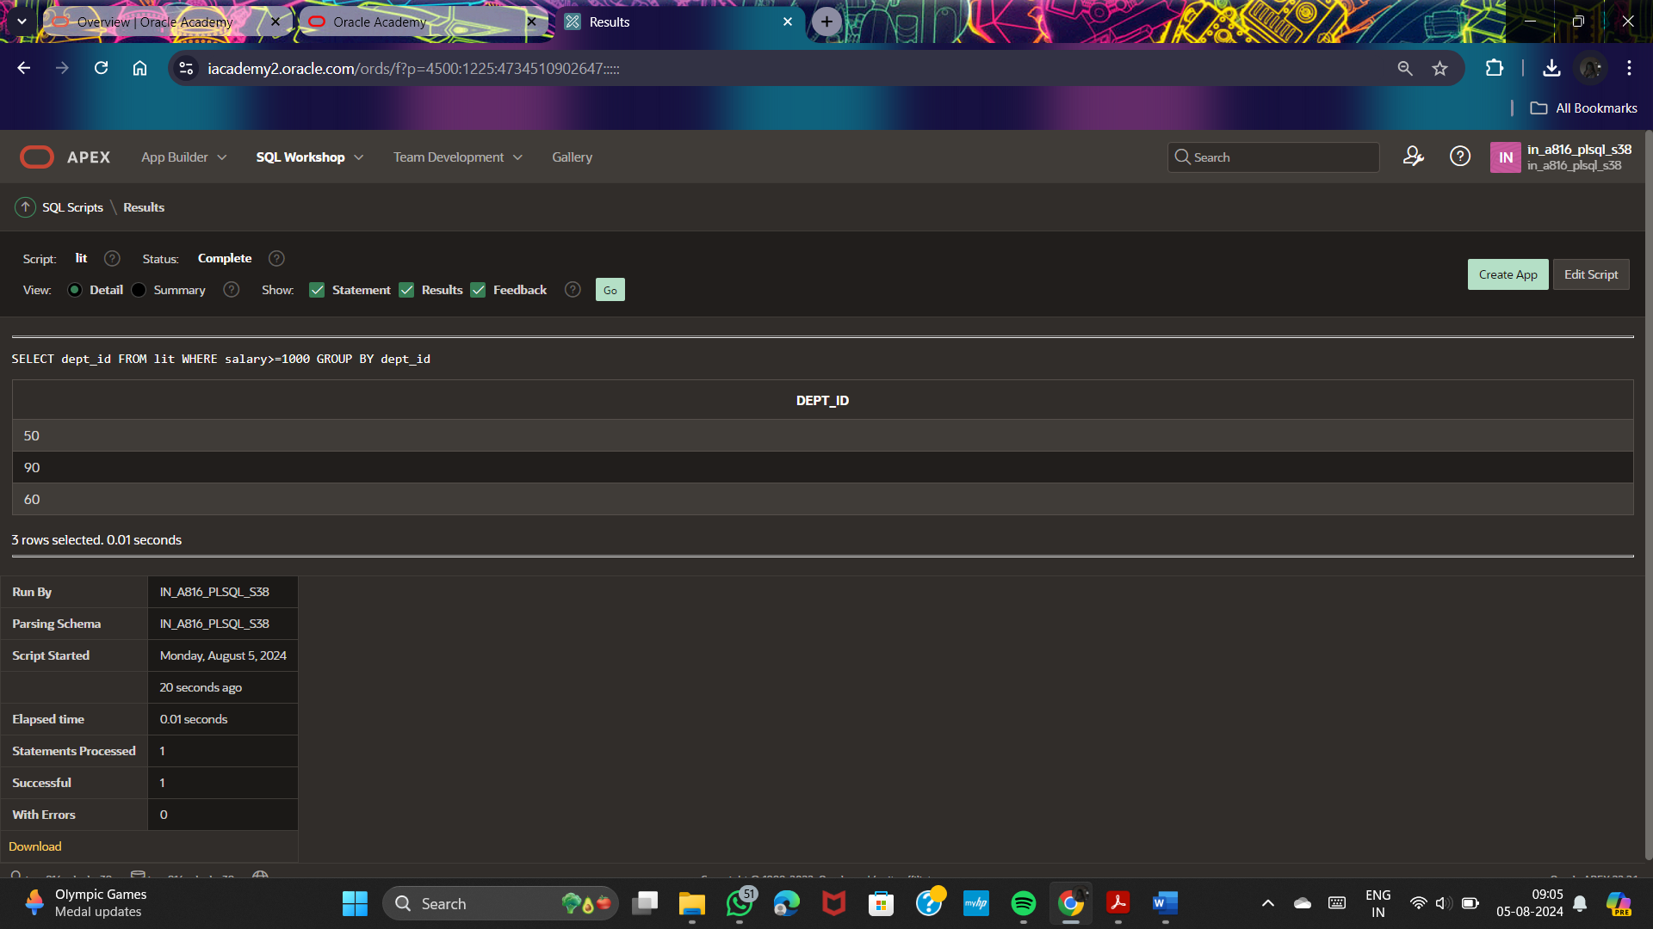

SELECT dept_id,firstname,lastname

FROM lit

WHERE salary>=1000

GROUP BY dept_id,firstname,lastname;

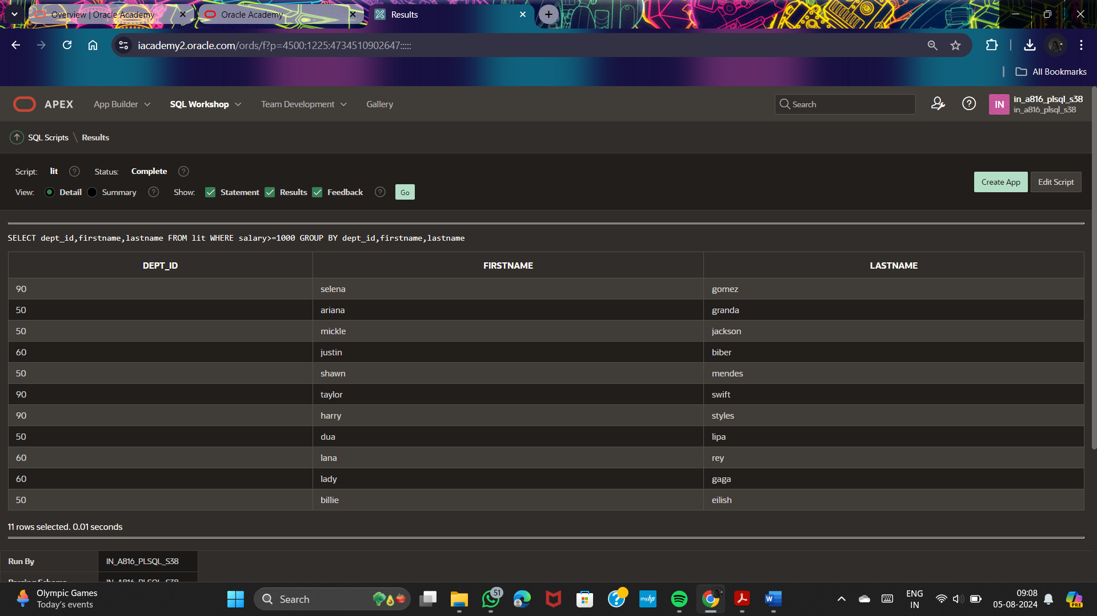

SELECT dept_id,firstname,lastname

FROM lit

WHERE salary = 9000

GROUP BY dept_id,firstname,lastname;

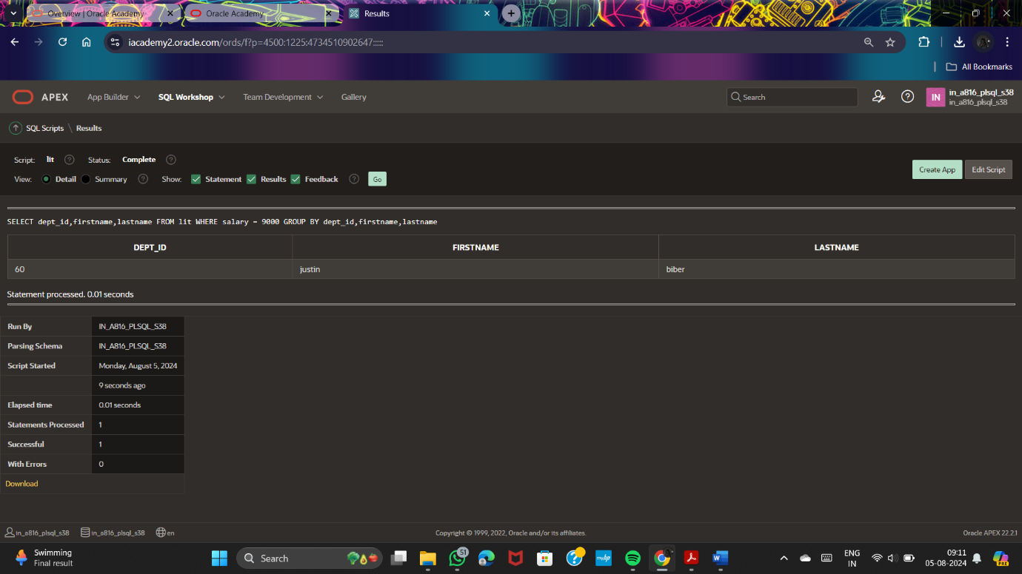

SELECT COUNT(dept_id)

FROM lit;

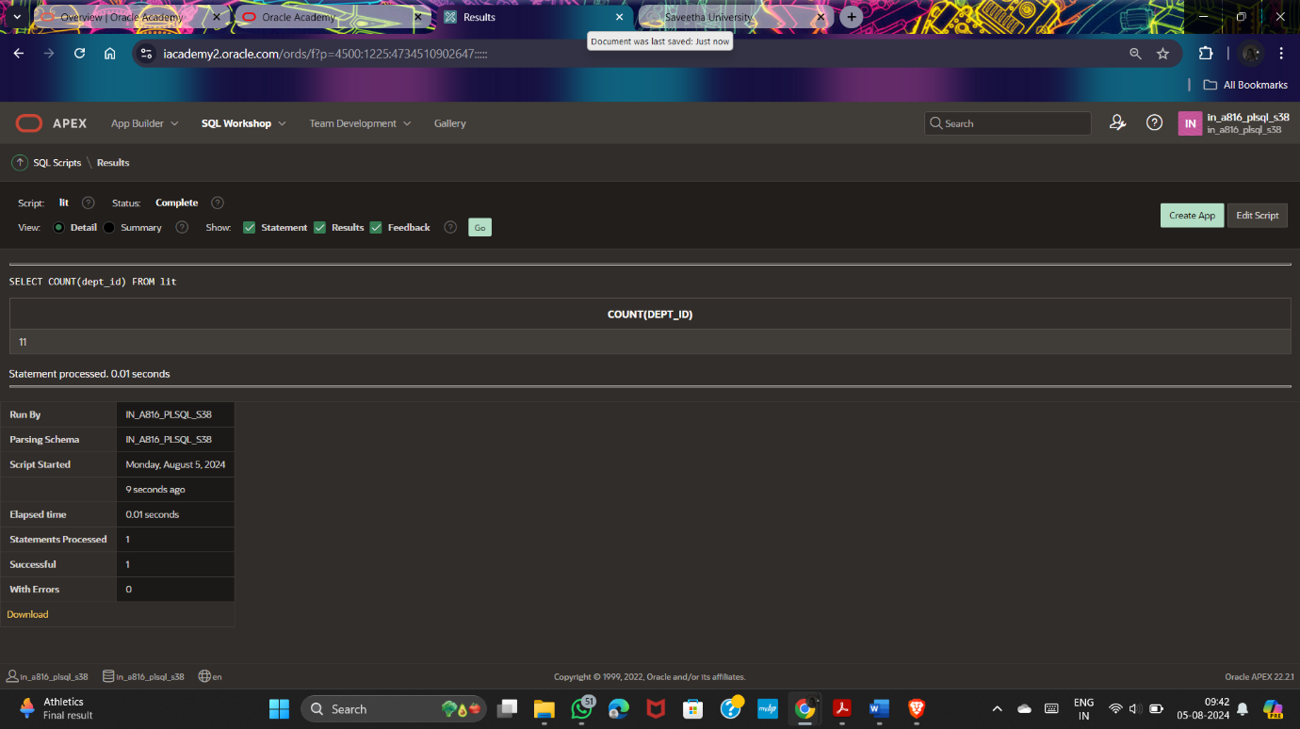

SELECT DISTINCT firstname

from lit;



SELECT AVG(NVL(dept_id,0))

from lit;

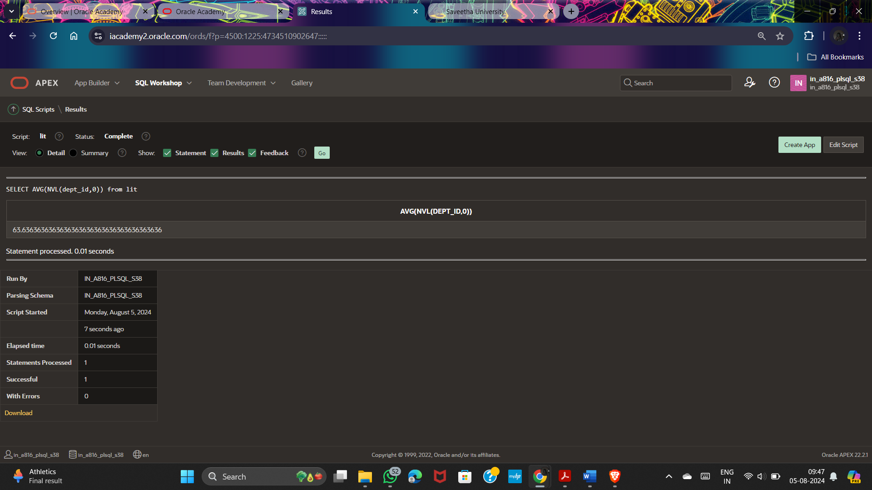

SELECT MIN(salary),MAX(salary),MIN(dept_id)

from lit;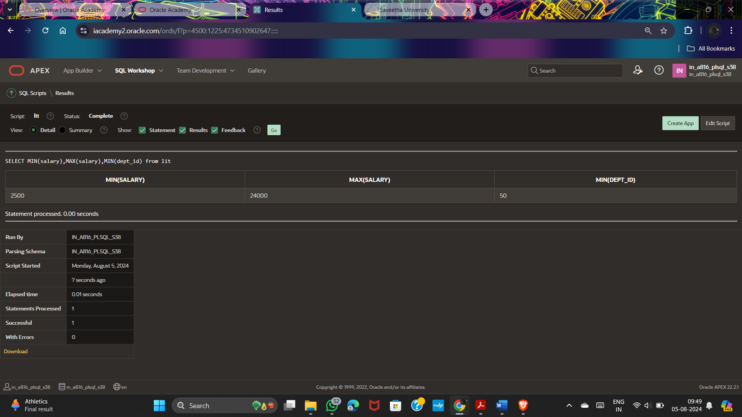

SELECT dept_id,AVG(salary)

FROM lit

GROUP BY dept_id

ORDER BY dept_id;

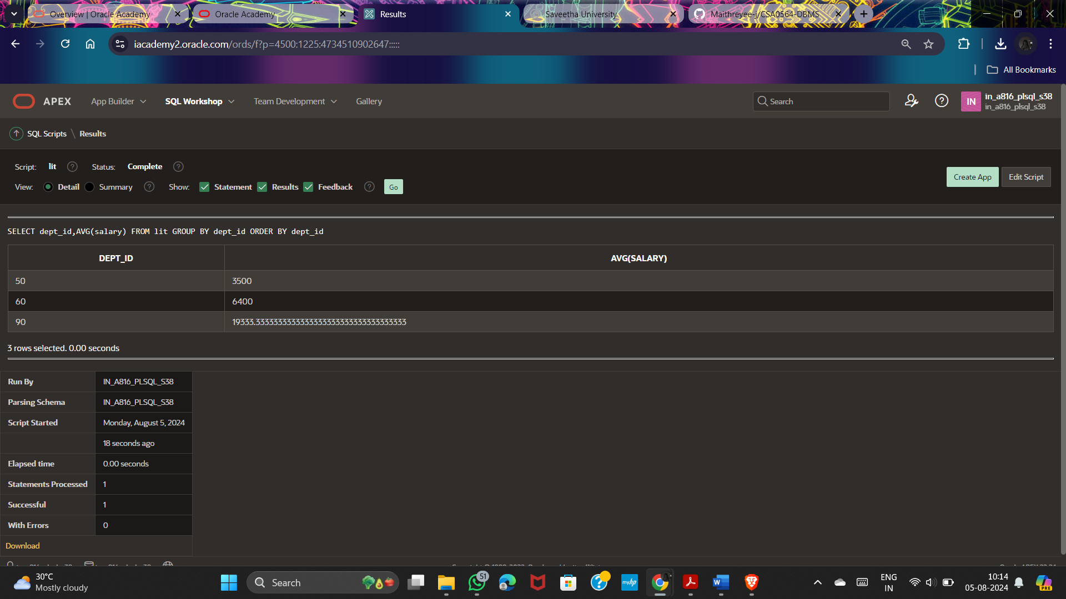

SELECT MAX(salary)

FROM lit

GROUP BY dept_id;

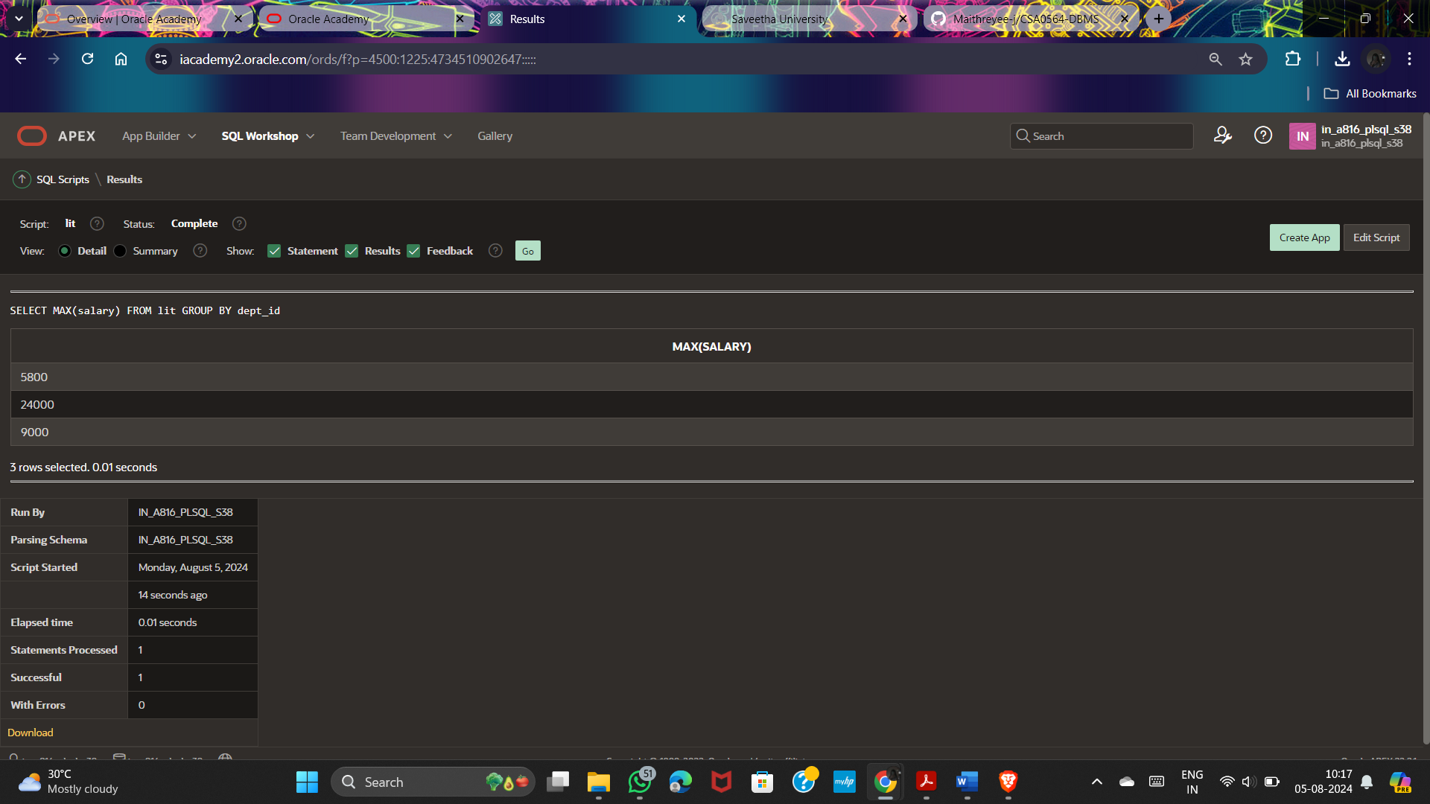

SELECT dept_id, MAX(salary)

FROM lit

where lastname != 'lipa'

GROUP BY dept_id;

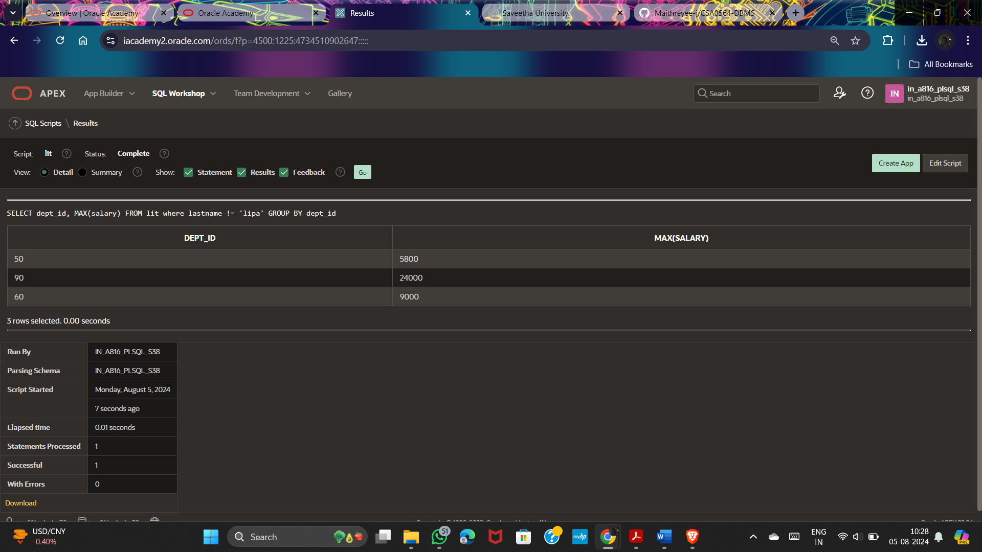

SELECT dept_id, MAX(salary)

FROM lit

GROUP BY dept_id

having count(*)>1

order by dept_id;

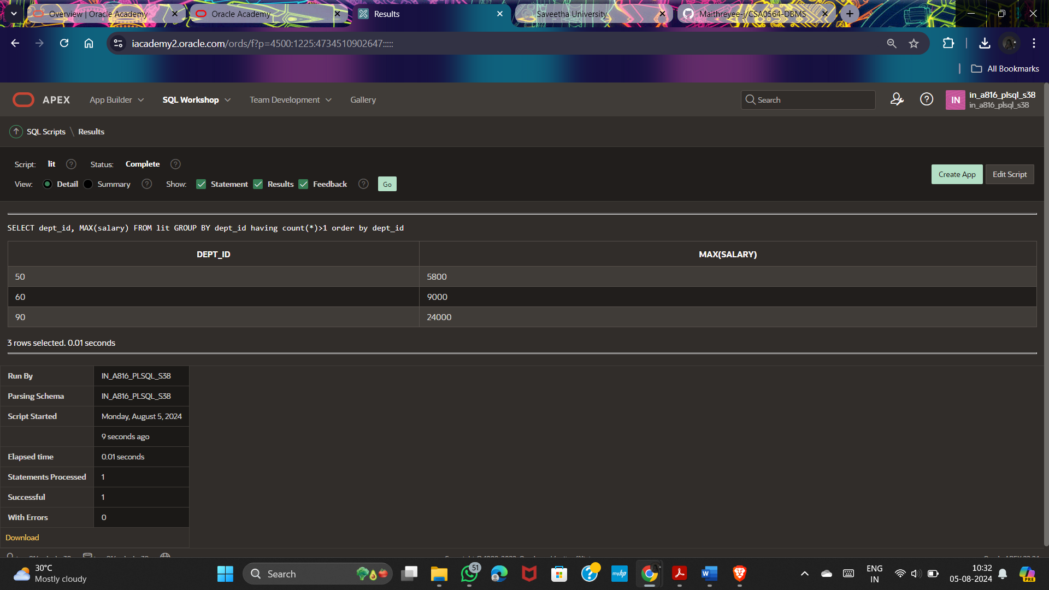

**MERGE:**

MERGE INTO copyemp c

USING myemp e

ON (c.employee_id = e.employee_id)

WHEN MATCHED THEN UPDATE

SET c.lastname = e.lastname,c.deptid = e.deptid

WHEN NOT MATCHED THEN INSERT(c.employee_id,c.lastname,c.deptid) VALUES(e.employee_id,e.lastname,e.deptid)

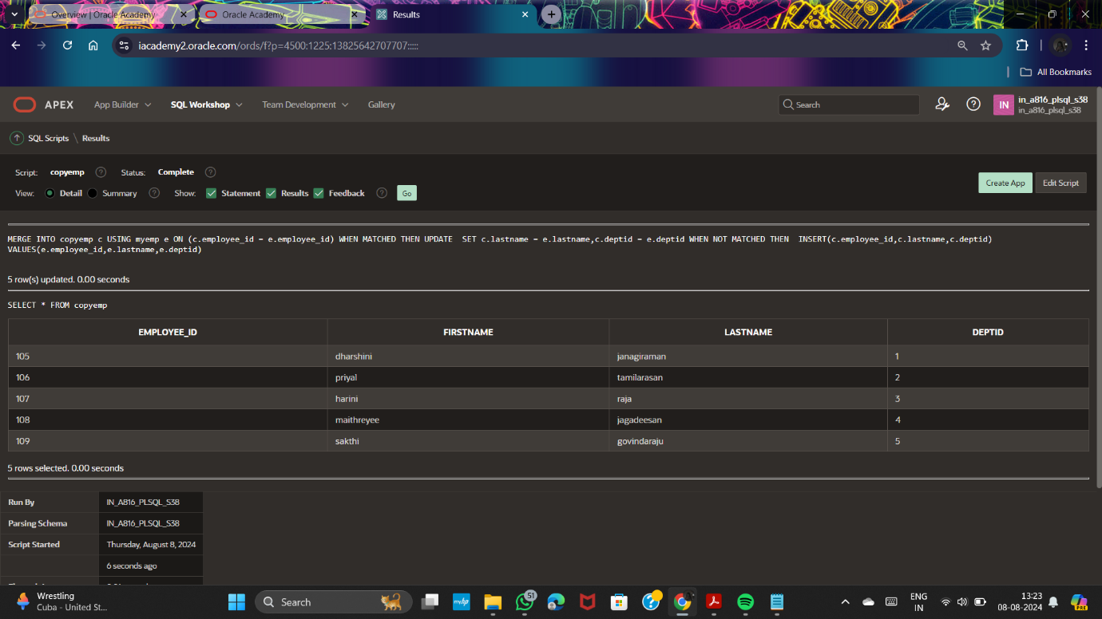

**SEQUENCE: example 1**

CREATE TABLE runners

(runner_id NUMBER(6,0) CONSTRAINT runners_id_pk PRIMARY KEY,

first_name VARCHAR2(30),

last_name VARCHAR2(30));

CREATE SEQUENCE runner_id_seq

INCREMENT BY 1

START WITH 1

MAXVALUE 50000

NOCACHE

NOCYCLE;

INSERT INTO runners

(runner_id, first_name, last_name)

VALUES (runner_id_seq.NEXTVAL, 'Joanne', 'Everely');

INSERT INTO runners

(runner_id, first_name, last_name)

VALUES (runner_id_seq.NEXTVAL, 'Adam', 'Curtis');

SELECT runner_id, first_name, last_name

FROM runners;

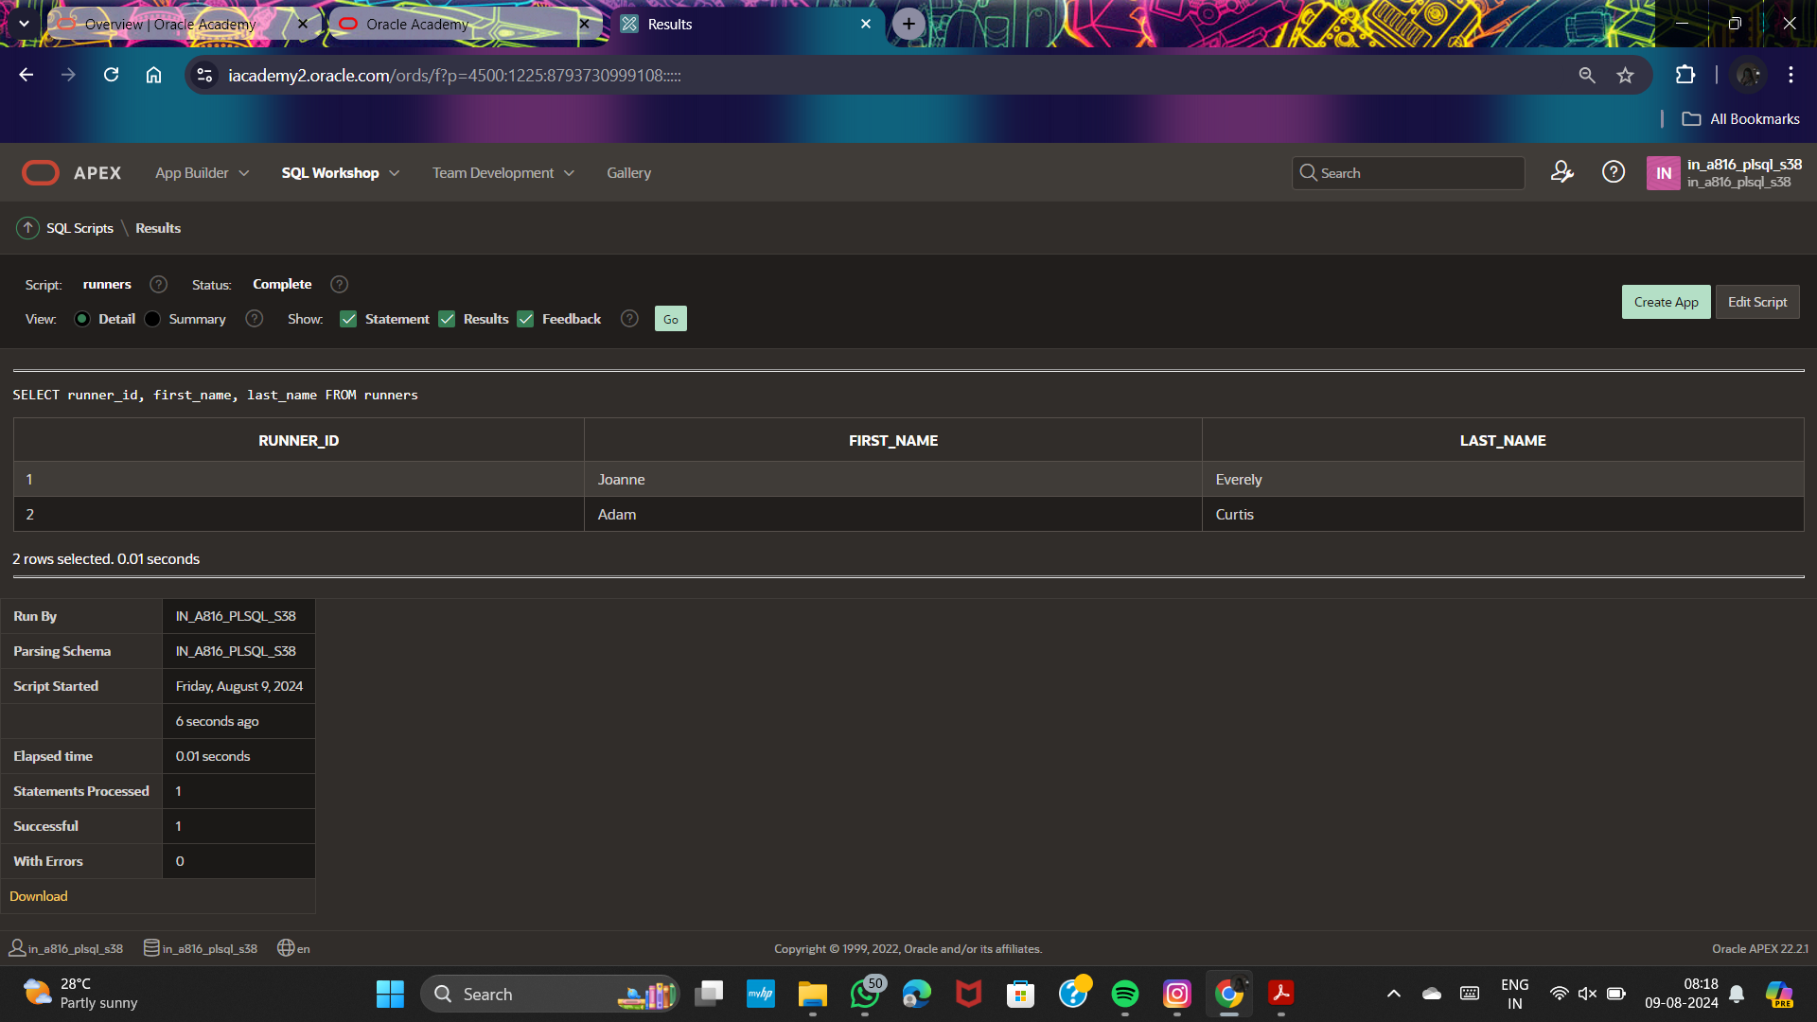

**Example 2:**

CREATE SEQUENCE sequence_1

INCREMENT BY 1

START WITH 1

MAXVALUE 50000

NOCACHE

NOCYCLE;

SELECT sequence_name, min_value, max_value, increment_by,

last_number

FROM user_sequences;

CREATE TABLE students

(

ID number(10),

NAME char(20)

);

INSERT into students VALUES

(sequence_1.nextval,'Shubham');

INSERT into students VALUES

(sequence_1.nextval,'Aman');

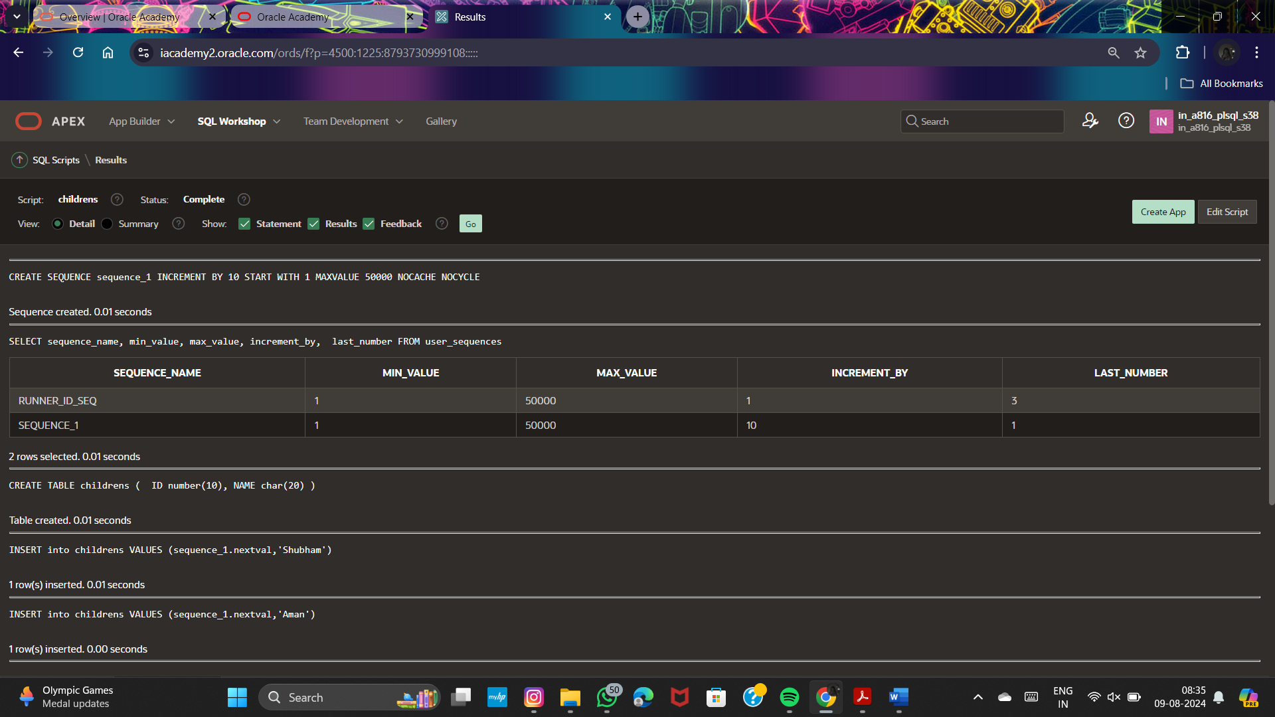

**Ensuring Quality Query Results - Advanced Techniques:**

CREATE TABLE empl

AS select * FROM copyemp

